**ANNOTATION SHEET – Evolutionary Extinction and Radiation Events:**

**Describe**:

1. Evolutionary radiation
2. Mass extinction

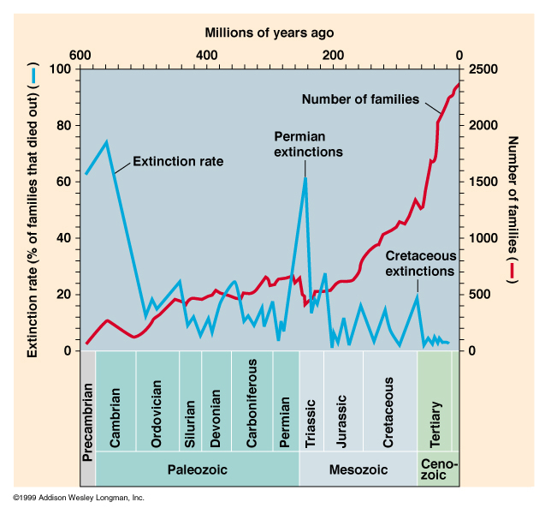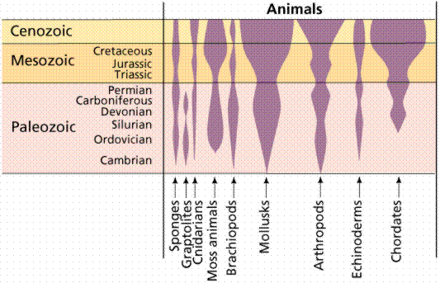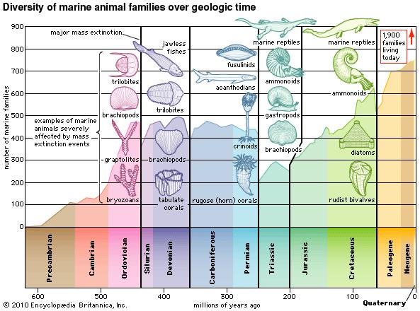**4.2.1 b - Analyse** each of the given data sets, to **determine** episodes of **evolutionary radiation** and **mass extinctions.**

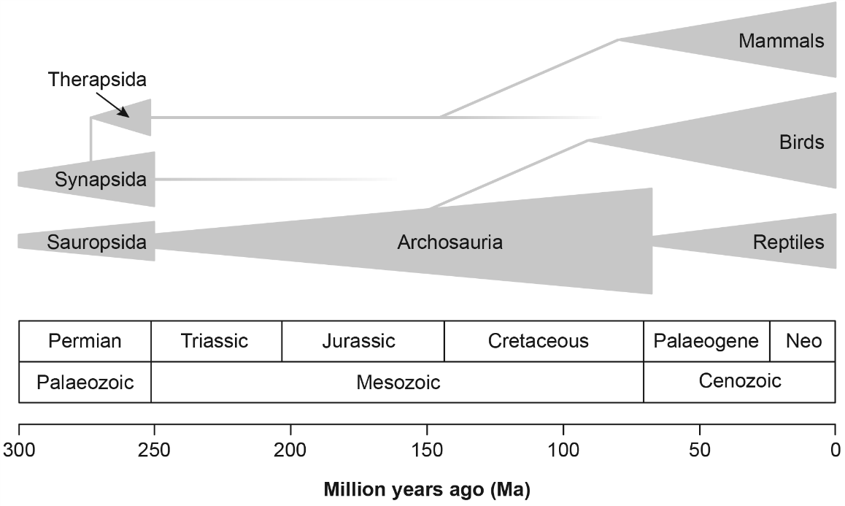

**EXIT TICKET:**

**4.2.1 b - Analyse** each of the given data sets, to **determine** episodes of **evolutionary radiation** and **mass extinctions.**

**SO MOCKEXAM 2020 SA 1**

**QUESTION 25 (2 marks)**

The figure below shows the diversity of marine animals since the late Precambrian time. The data is from marine animal families that have been reliably preserved in the fossil record.

Identify a geological period of evolutionary radiation and geological period of mass extinction.

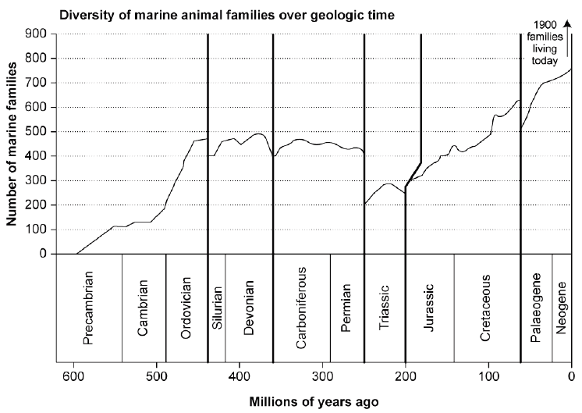

Evolutionary radiation: __________________________________________________________________

Mass extinction: _______________________________________________________________________